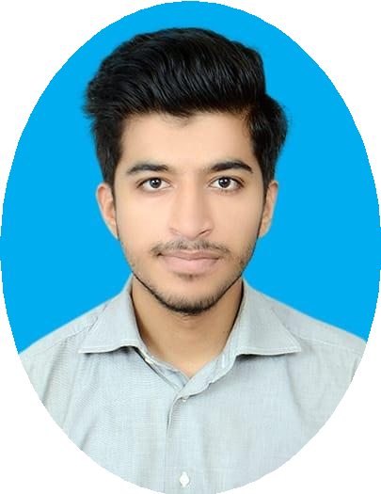

|  |  |
| --- | --- |
|  | **MUHAMMAD ALI**  **INNOVATOR - QUICK LEARNER - PROBLEM SOLVER** |
| **PROFILE**  I am a student and learner currently enrolled in Bachelors in Computer Science at National University of Computer & Emerging Science (NUCES FAST).  **SKILLS & LANGUAGES**   * C * C++ * HTML * CSS * JAVSCRIPT * OOP * DATA STRUCTURES * REACT * PHP * SQL * PYTHON * WORDPRESS * COAL   **CONTACT**  **PHONE:** 0311 2897912  **ADDRESS:** P-111, Punjab Town, Wireless Gate, Karachi.  **EMAIL:** asafder902@gmail.com  **Website**: <http://muhammadaliportfolio.surge.sh/>  **HOBBIES**   * Programming * Reading * Gaming | **EDUCATION**   * Done Matric from CAA Model School 1Having A+ Grade (86.59%) in 2017. * Intermediate from DJ Sindh Government Science College Having A Grade (71.69%) 2017-2019. * Under Graduation from Department of Computer Science, National University of Computer & Emerging Science (NUCES FAST), third year student currently enroll in 6th Semester doing Computer Science 2019- 2023. * Completed 1 year course of Artificial Intelligence at Presidential   Initiative of Artificial Intelligence & Computing (PIAIC).  **PROJECT & WORK EXPERIENCE**   * I have done a project of Cafeteria Management System with my friends in C. * I have also done a project of Library Management System with my friends in C++. * I have also participated two times in ACM CODER’S CUP in   university.   * I have also three months of PR experience in NU_FEST Society. * I also made a simple mobile Blog App in React native. * I have three months of teaching experience at IJK Coaching Center. * I have three months of experience as a sales agent in Fast Lead Solution. * I have done multiple projects in React and JavaScript which you can see in my portfolio.   **ADDITIONAL SECTION**  I am a motivated and Innovative student. I always try my best to give my 100% in every field and love to do programming and making wonderful things. Currently I am learning MERN stack development and wanted to pursue my career as a Web developer. I really wanted to join your team and to learn amazing things, hope I can work with your team in future. |